**Selenium Download PDF**

Step 01: Search Selenium jar download in google

Step 02: Click on the Downloads | Selenium

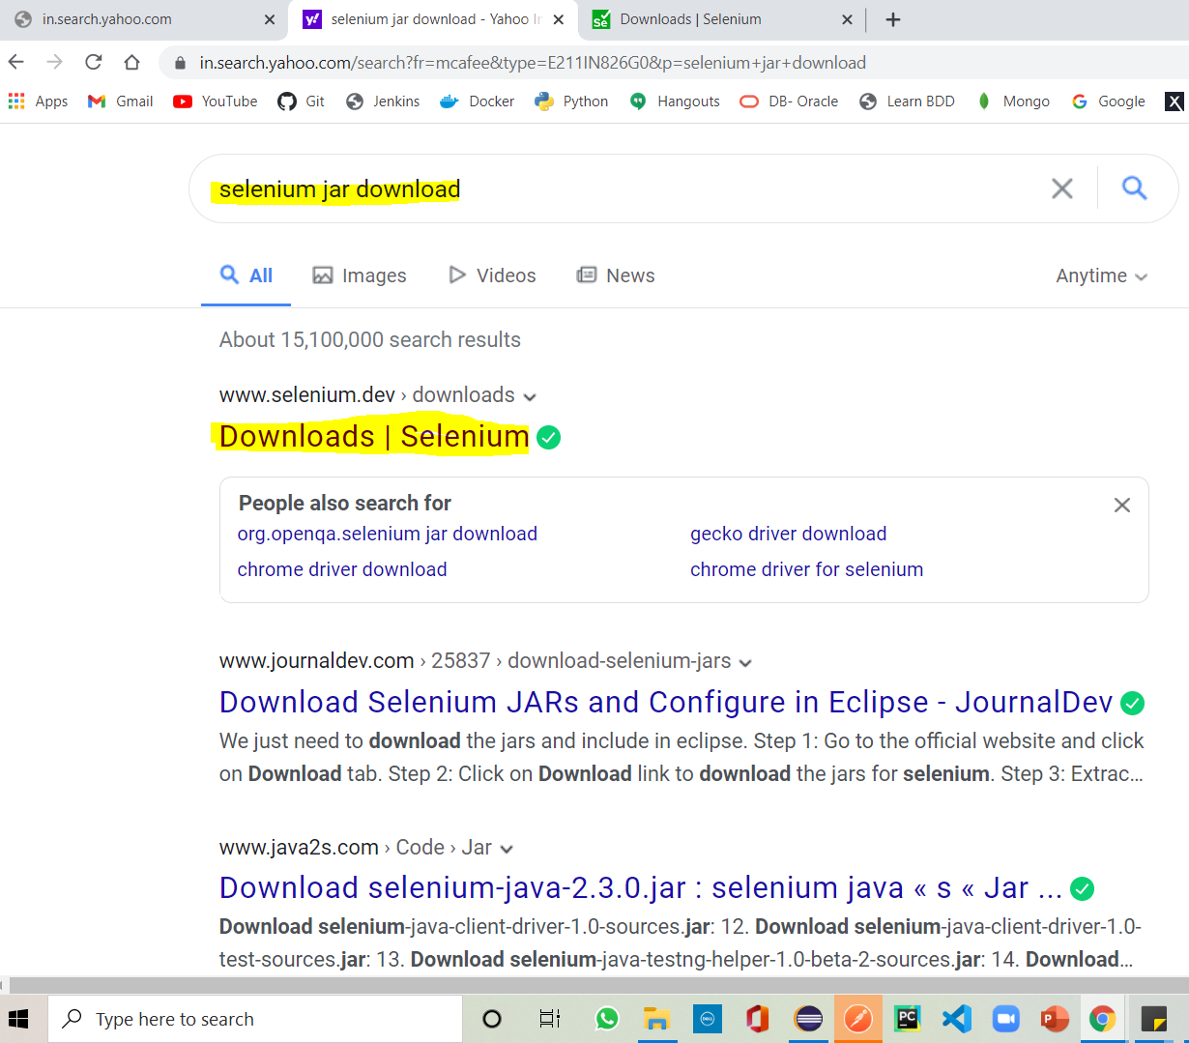

Step 03: Scroll down and click here in the Previous release. Then expand the version 3.141.59 and select selenium-server-standalone-3.141.59 jar.

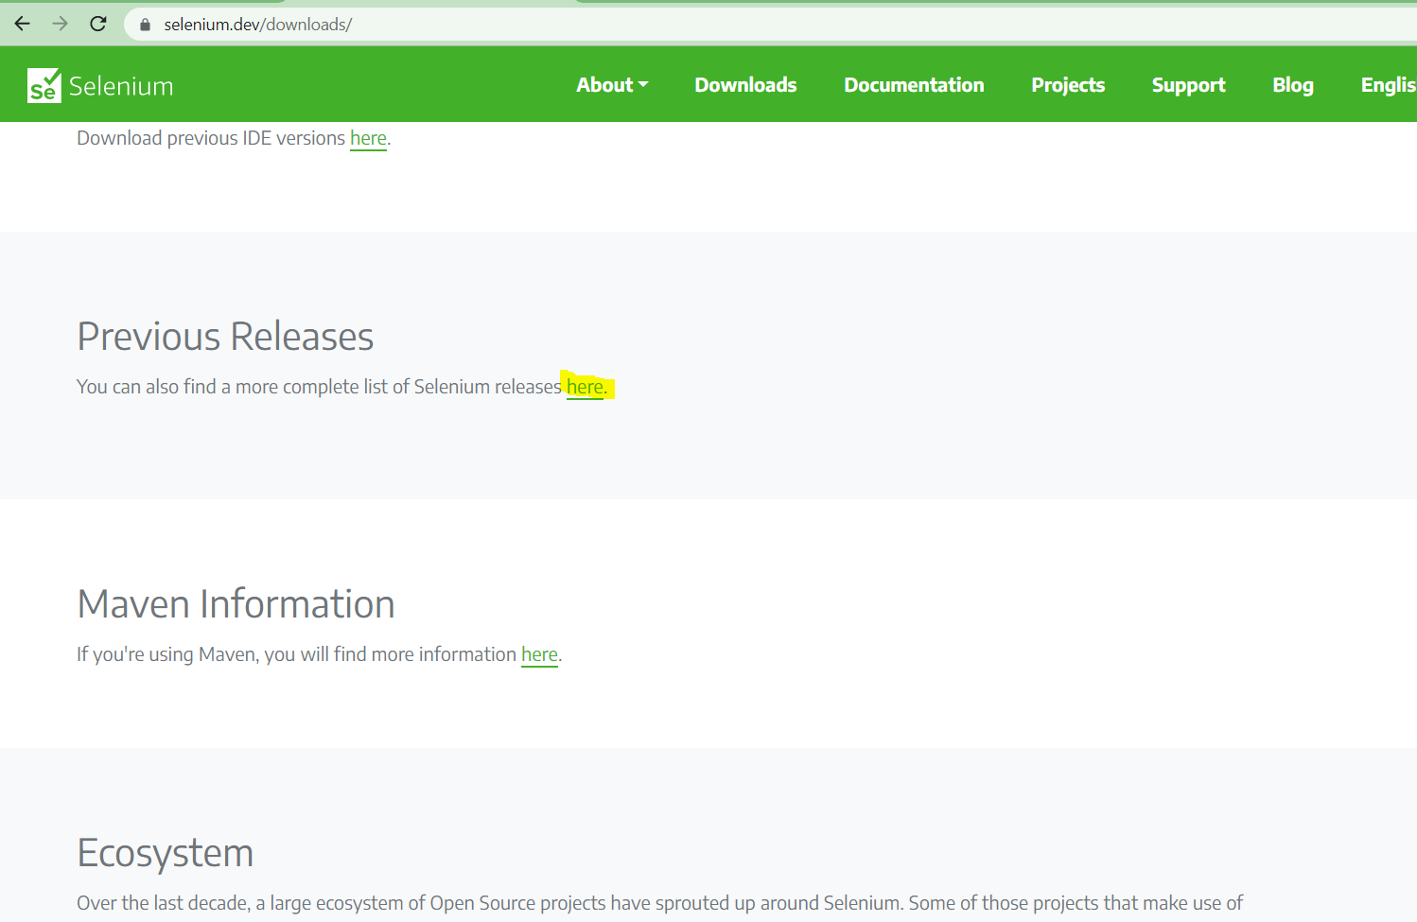

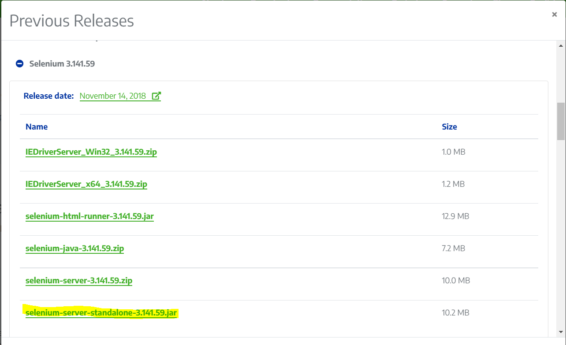

Step 04: The jar folder will be downloaded in the end of the page.

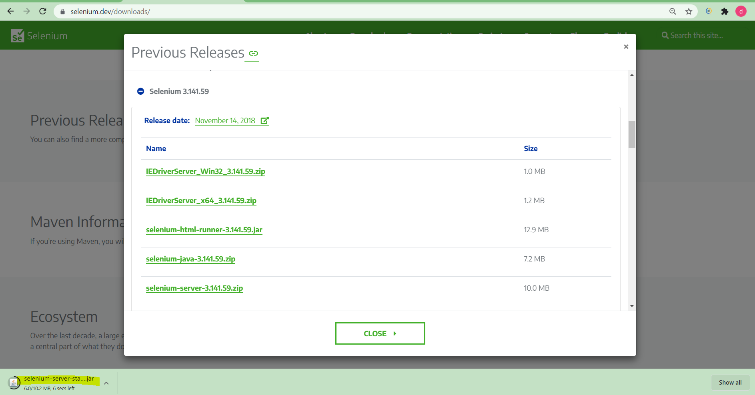

Note: It will ask for the permission so click on “Keep”.

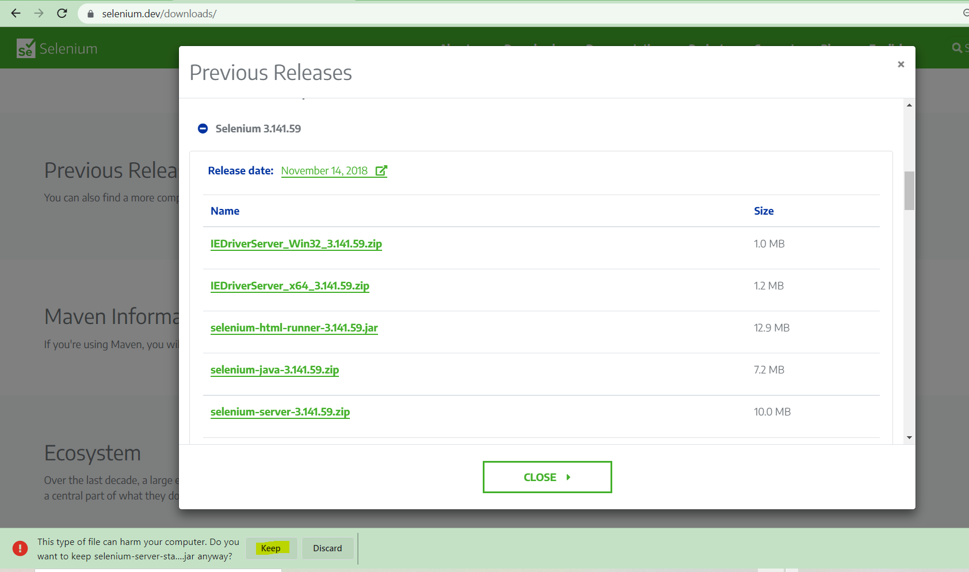

Step 05: Create new folder in Desktop and name as “Selenium”.

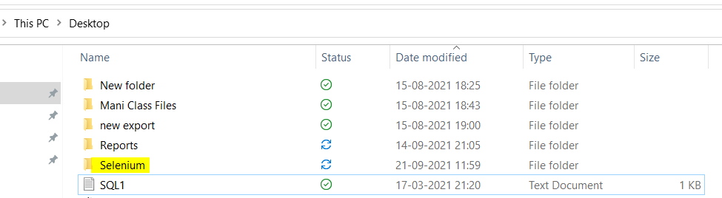

Step 06: Copy the jar file from Downloads and Paste it in the selenium folder.

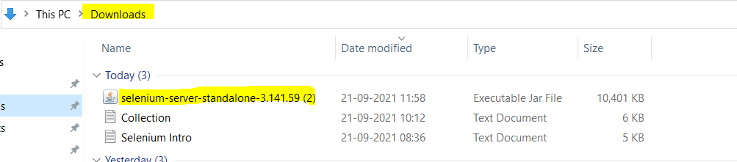

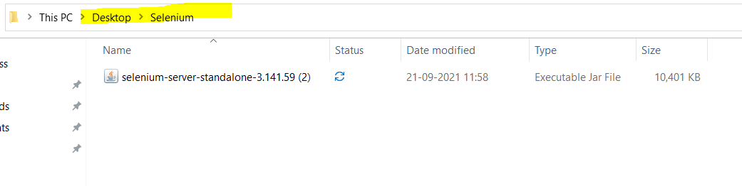

Step 07: In Eclipse create a new project and right click on the Project > Build Path > Configure Build Path > Libraries > click on Add External JARs

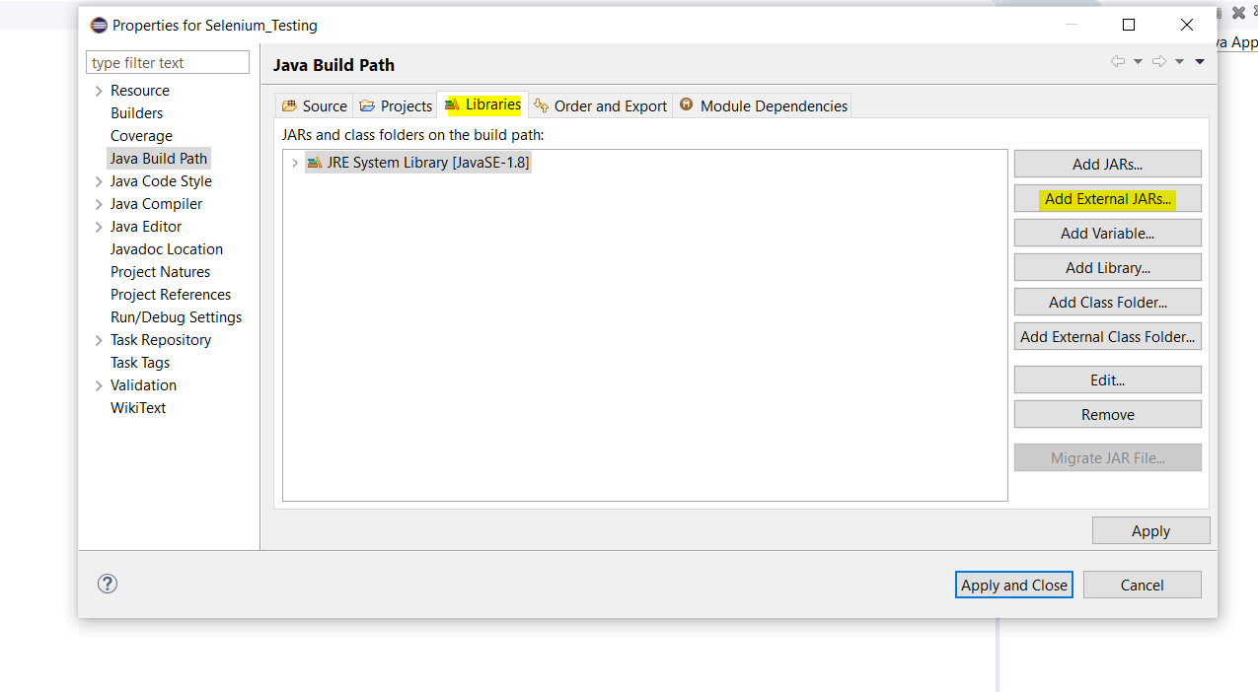

Step 08: Select the jar file from selenium folder and click on Open.

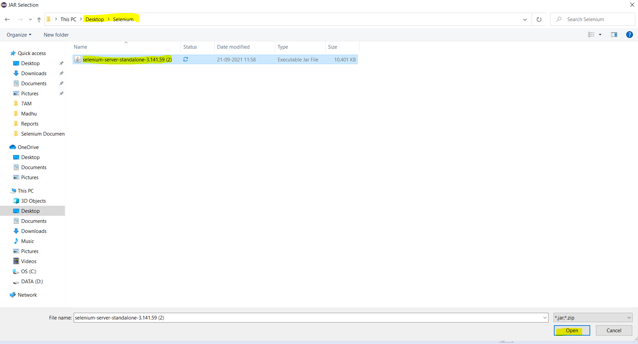

Step 09: Now click on Apply then click on Apply and Close.

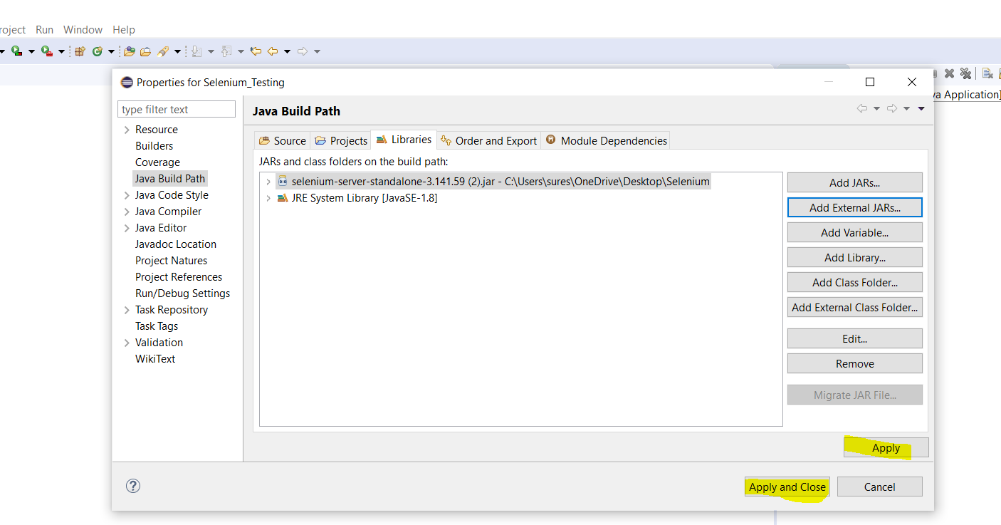

Step 10: Verify the jar file is added under the Reference Libraries.

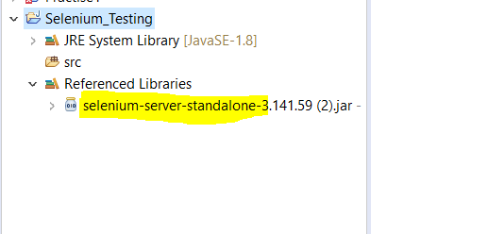

Step 11: Right click on the Project created in Step 07 and create a New Folder and name as “Driver”.

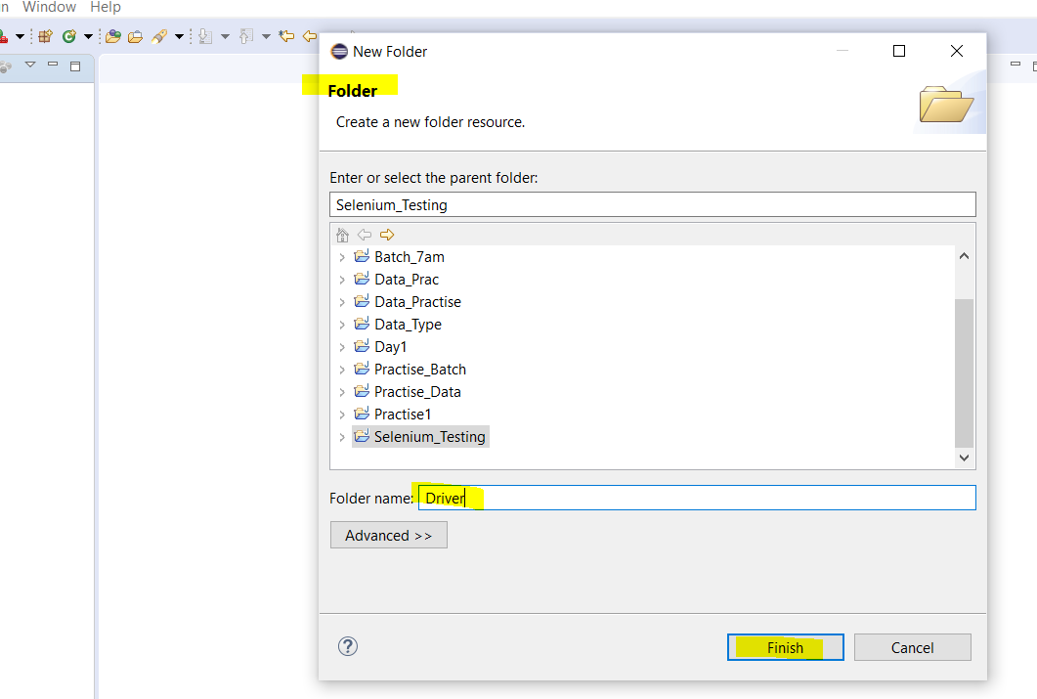

Step 12: In Google search Selenium jar download click on Downloads | Selenium.



Step 13: Scroll down and expand the Browsers then click on the documentation in Chrome

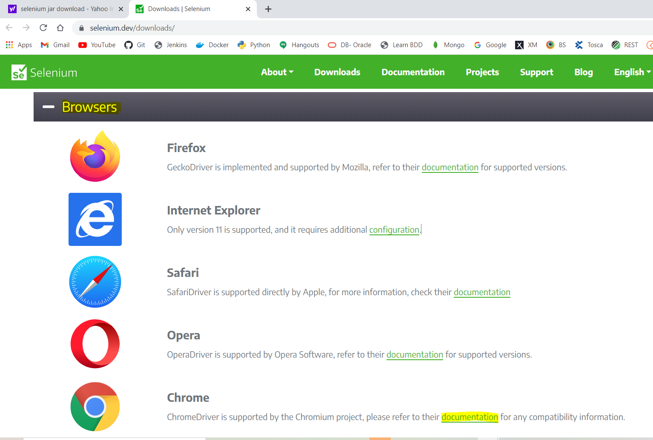

Step 14: Check the Chrome Version before downloading.

How to check the Chrome Version:

🡪Click on the 3 dots in the right corner of the window > Help > About Google Chrome > check the version and then download the same ChromeDriver version.

For example: If Chrome version is 93 then download the ChromeDriver with version 93.

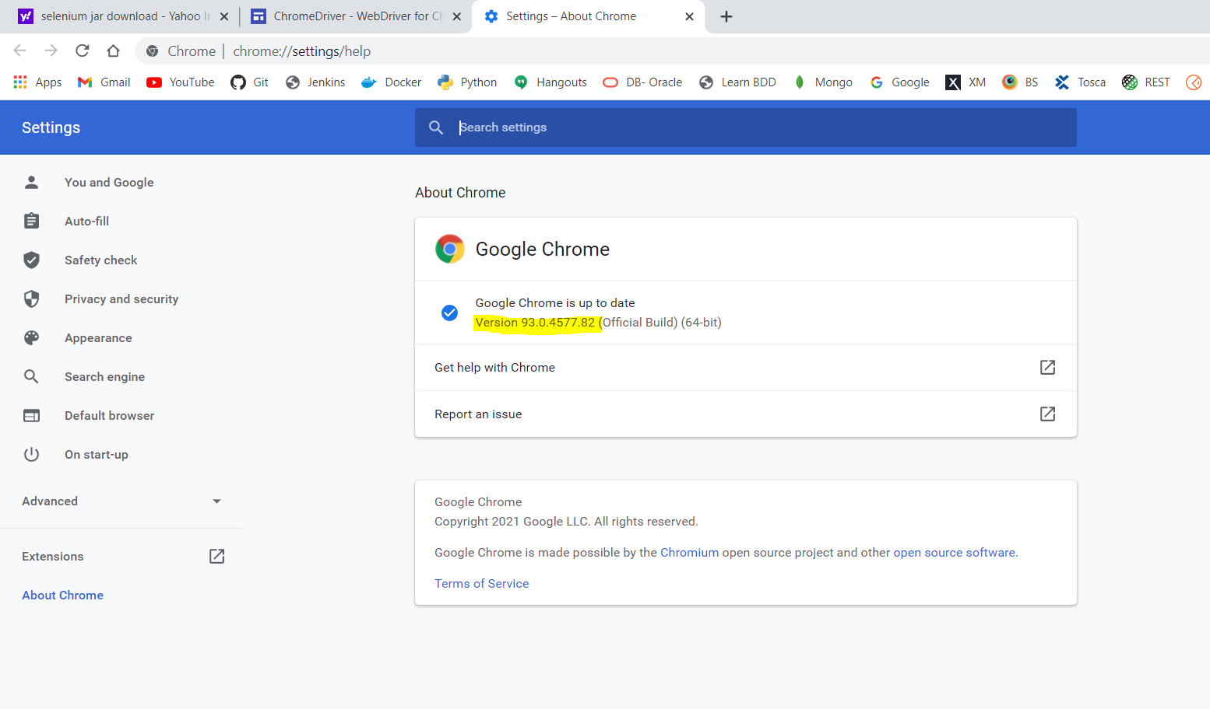

Step 15: Now click on the Latest Stable release ChromeDriver 93.0.4577.63 version.

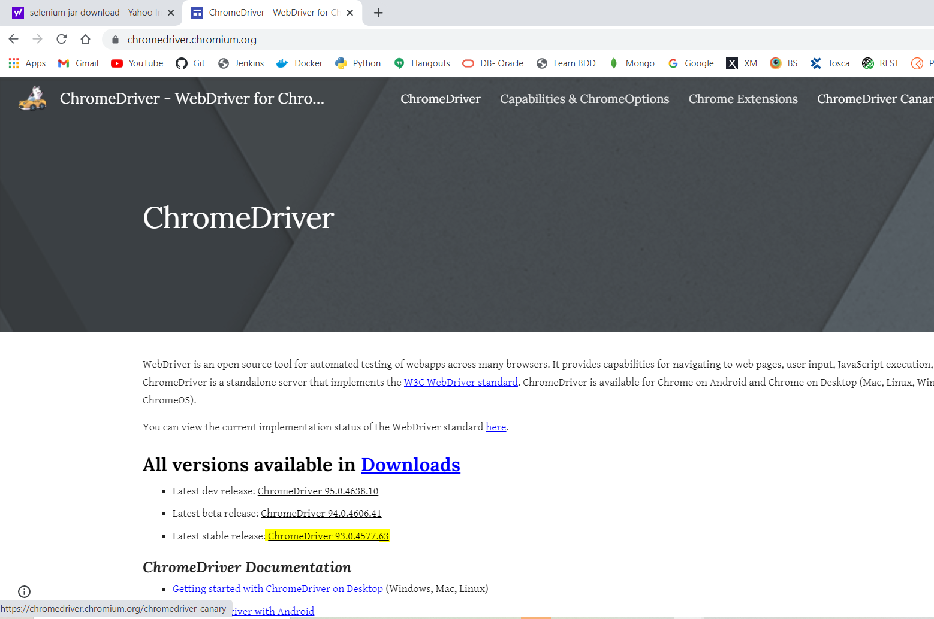

Step 16: Click on the chromedriver_win32.zip and Make sure the chromedriver_win32.zip is downloaded in end of the page

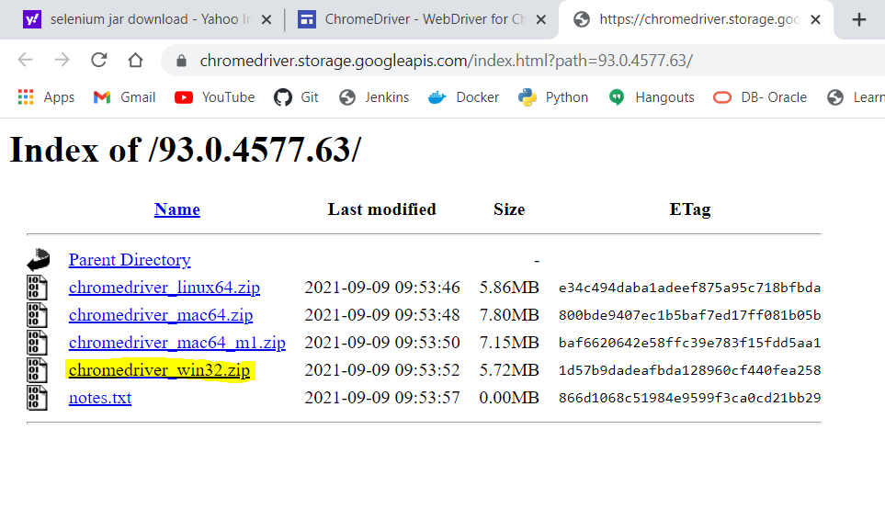

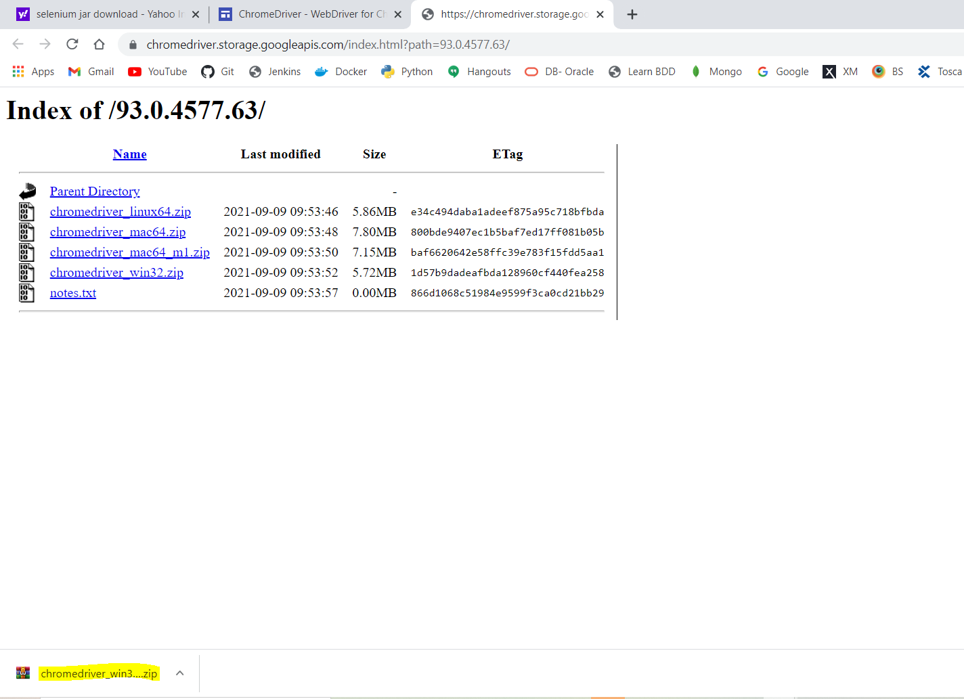

Step 17: From the Downloads Extract the file and save in Selenium folder

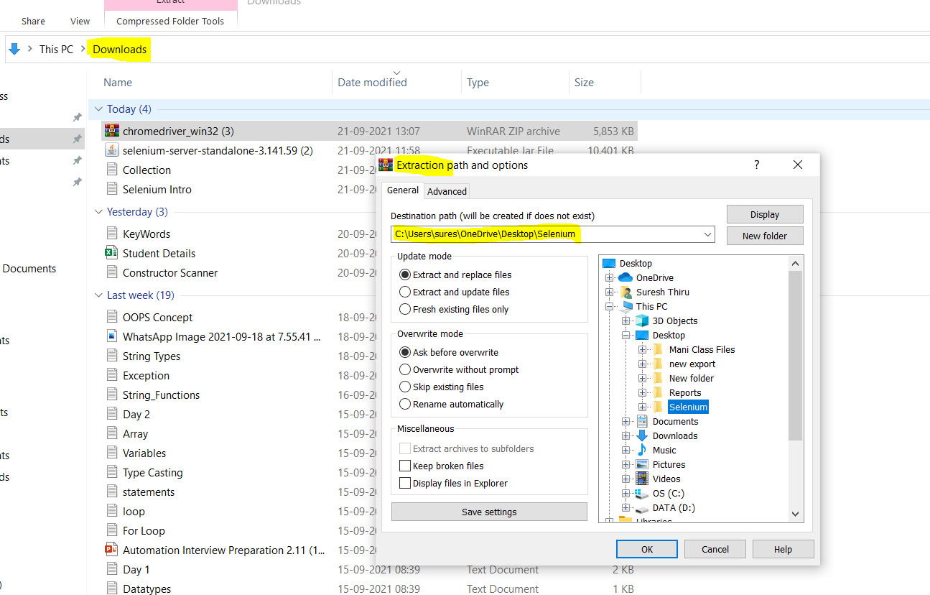

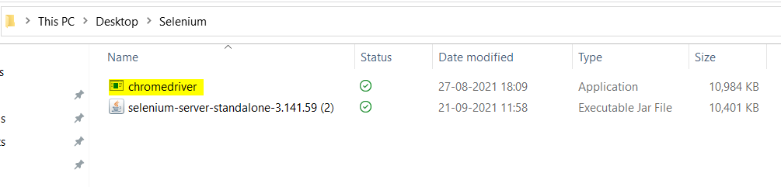Step 18: Now Copy the chromedriver from selenium folder and paste it in the Driver folder created inside the eclipse.

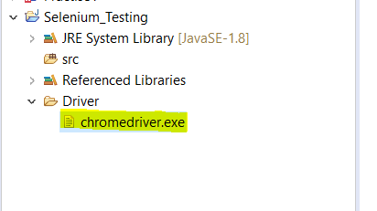

**\*\*\*THE END\*\*\***